Patient Portal
User Manual

Projekt-Kürzel: POWER2DM
Projekt-Name: „Predictive model-based decision support for diabetes patient empowerment”
Projekt-Kennzeichen: H2020-PHC-689444
Projekt-Webseite: http://www.power2dm.eu/
Dokument-Erstelldatum: 2019-11-06

Table of Content
1. Introduction 3
2. Login Patient Portal 4
3. Home Page 5
4. Treatment 7
4.1. Treatment Plan 7
4.2. Medication 7
4.3. Barriers 8
5. Action Plan 9
5.1. Self-Management Goals 9
5.2. Calendar 9
5.3. Review 13
Overall Performance 13
Activity Feedback 14
Journal Feedback 14
Goals Feedback 15
Charts 16
5.4. Charts 16
5.5. Energy Battery 17
5.6. Value Compass 20
5.7. Relaxation Tips 24
5.8. Favorite Goal 24
6. Journal 26
Adding a new journal entry 26
7. Information (“?”) 30
7.1. EMPOWER Information Material 30
7.2. User Manual 30
8. User Options 32
8.1. Settings 32
8.2. Timing 33
8.3. Logout 34

Introduction

POWER2DM (Predictive model-based decision support for diabetes patient empowerment) is a Horizon 2020 project funded by the EU (ref. H2020-PHC-689444). The main objective of POWER2DM is to develop and validate a personalized self-management support system for Type 1 and Type 2 diabetes patients that combines and integrates:

- A decision support system based on leading European predictive personalized models for diabetes interlinked with predictive computer models,
- An automated e-coaching functionalities based on Behavioural Change Techniques, and
- Real-time Personal Data processing and interpretation.

More information can be found at the POWER2DM website (http://www.power2dm.eu/about/).

This User Manual provides support for the usage of the POWER2DM patient portal, the so-called Action Plan Engine.

The Action Plan Engine guides the user through his/her diabetes self-management process supporting the specification of self-management goals based on the physicians’ treatment goals and treatment plans, and the planning of self-management activities based on these goals. Based on recorded data from the web or mobile app, the Action Plan Engine will provide feedback about how successfully you have met your goals and activities as well as recommend interventions for optimising your self-management activities.

Login Patient Portal

The Patient Portal handles highly sensitive personal and medical data. Therefore, the login procedure protects your data from non-authorized access. Both username and password are provided to the patient during the patient registration. Depending on the used POWER2DM installation, either the Netherlands or Spain, the Login Page may differ slightly.

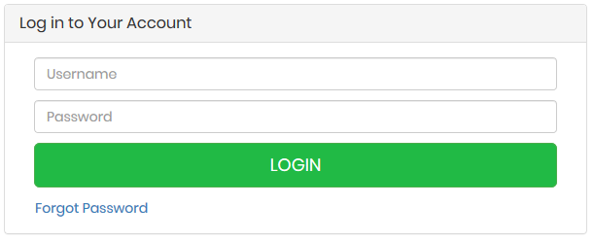
Figure 1: Login Page

Home Page

After a successful login, you will be redirected to the POWER2DM home page.

In the upper area of the screen you find the menu. With the menu bar, all the functions of the POWER2DM patient portal are available.

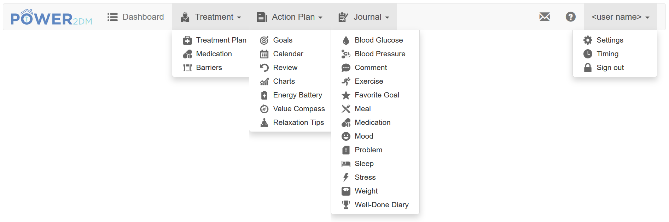
Figure 2: Menu Bar Overview

The main menus also contain several sub-menus as shown in Figure 2. The distinct menu items are as follows:

- Treatment: Lists the personal treatment plan (goals and activities), medication and detected barriers from your doctor. This data cannot be edited; instead, active data (highlighted in blue) can be adopted to your self-management goals and activities. Your self-management goals are the basis for planning self-management activities that can be scheduled and displayed in your calendar.
- Action Plan: Allows you to review and to specify your personal goals, typically based on the doctor’s treatment plan, opens your calendar with your activities, offers you a review of the past activities and give access to charts. In addition, it contains three tools, the Energy Battery, the Value Compass and the Relaxation Tips.
- Journal: Collects and reviews your data.
- Letter icon: Displays your inbox messages (e.g. reminders, timed interventions, etc.) just like the mobile application. You can dismiss a message by clicking on it.
- Question mark icon: Provides additional information with respect to diabetes and its implications and includes this user manual.
- <user name>: Includes the settings for the Action Plan Engine, the settings for event-based timings and the button to sign out.

The POWER2DM logo and dashboard item (see Figure 2) within the menu bar opens the home screen again. The homepage includes a dashboard with an overview of your most important data for the current week. All items are colour coded using the following pattern:

- Green – Everything is complete/okay
- Orange – Something should be in progress at the moment
- Red – Something is incomplete/wrong
- Grey – Something to come up in the future / additional information

The items to be shown at your dashboard can be configured in the settings (see section 8.1.). Figure 3 gives an overview about the dashboard items:

- Time selection window – allows the current time window to be viewed on suitable pages (shown on the top right)
- Overall performance – of the current week
- Upcoming activites - lists current and upcoming events of today and tomorrow. The user can enter results for incomplete events by clicking the corresponding activity.)
- Charts – the user can display a chart for the past week by selecting a chart type

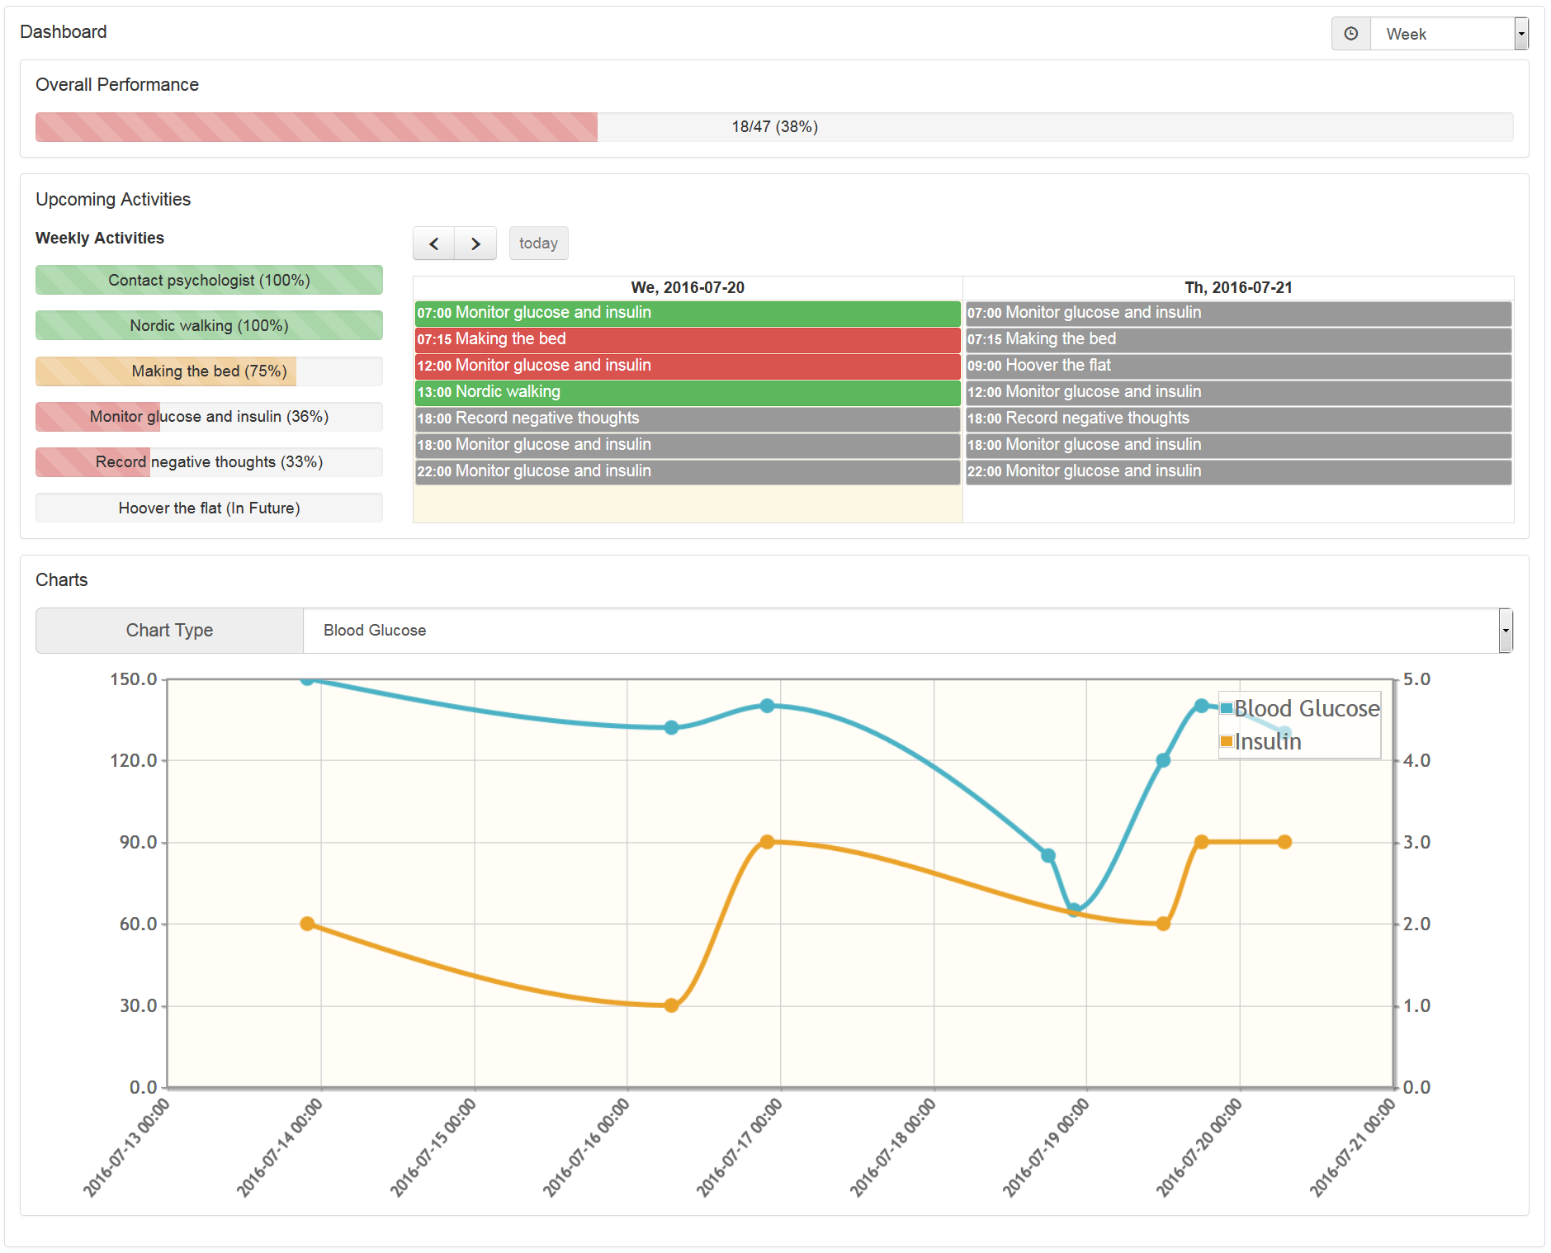
Figure 3: Dashboard

Treatment

The Treatment menu item is the interface to your physician and contains the Treatment Plan, your medication list und barriers identified with your physician.

Treatment Plan

This menu item lists the patients’ personal Treatment Plan from his/her doctor (see Figure 4). A Treatment Plan consists of one or more Treatment Goals. A Treatment Goal can in turn include one or more Treatment Activities suggested by your doctor to help achieve your treatment goal. The Start Date and the Target Date indicate the valid period for a Treatment Goal. The Target Value indicates what the Treatment Goal aims to achieve.

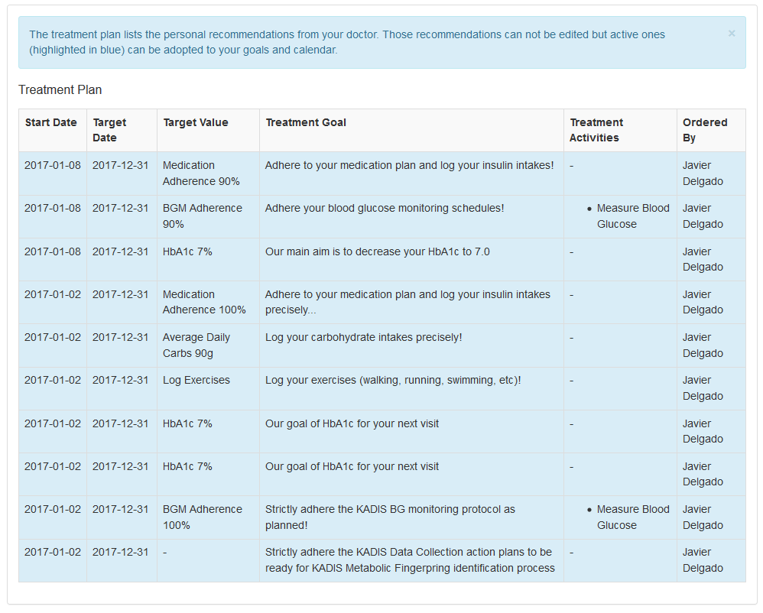
Figure 4: Treatment Plan

To adopt a Treatment Goal as one of your personal self-management goals or to schedule a Treatment Activity in your calendar, just click on the Treatment Goal. You can then also refine the planning, e.g. adding a more detailed description to the goal or adapting the schedule for the activity. Afterwards, your scheduled activities will appear in calendar.

Medication

This menu item lists the medication and dosage prescribed by your physician. By clicking on a medication the user can adopt the selected medication as an activity in the Action Plan Calendar.

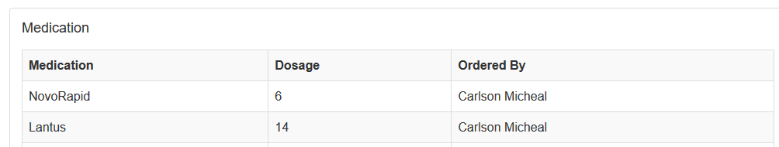
Figure 5: Medication List

Barriers

This menu item lists the barriers detected by your physician or automatically added during the use of the Action Plan Engine. Barriers can only be edited by your physician but you can delete the automatically added ones by clicking on them.

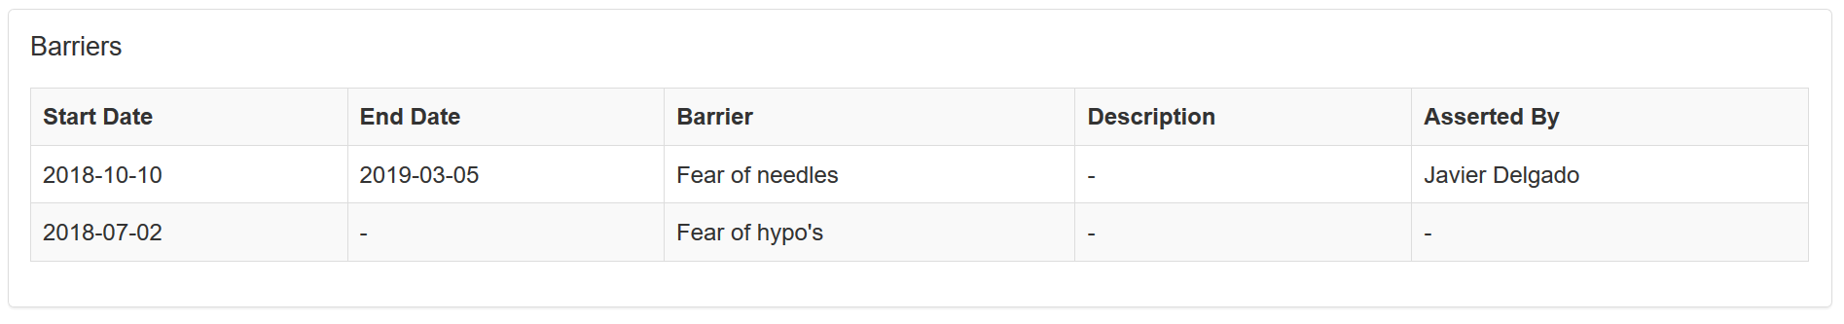
Figure 6: Barrier List

Action Plan

The Action Plan menu enables you to list, evaluate, edit and review the relevant personal information. This includes the management of personally defined goals, the management of planned activities (to achieve the defined goals), the review for your activities and the charts. Additionally, this menu item includes three tools, the Energy Battery, the Value Compass and the Relaxation Tip Editor.

Self-Management Goals

Sometimes the treatment goals of the medical care providers are more general, e.g. “Do some sports” or “Reduce weight”. To react to those treatment goals, the POWER2DM patients’ portal allows you to define concrete individual goals tailored to your specific requirements and needs, e.g. “10 km running each week”. To finally achieve your personal goal, you may later assign planned activities to the personal goals.

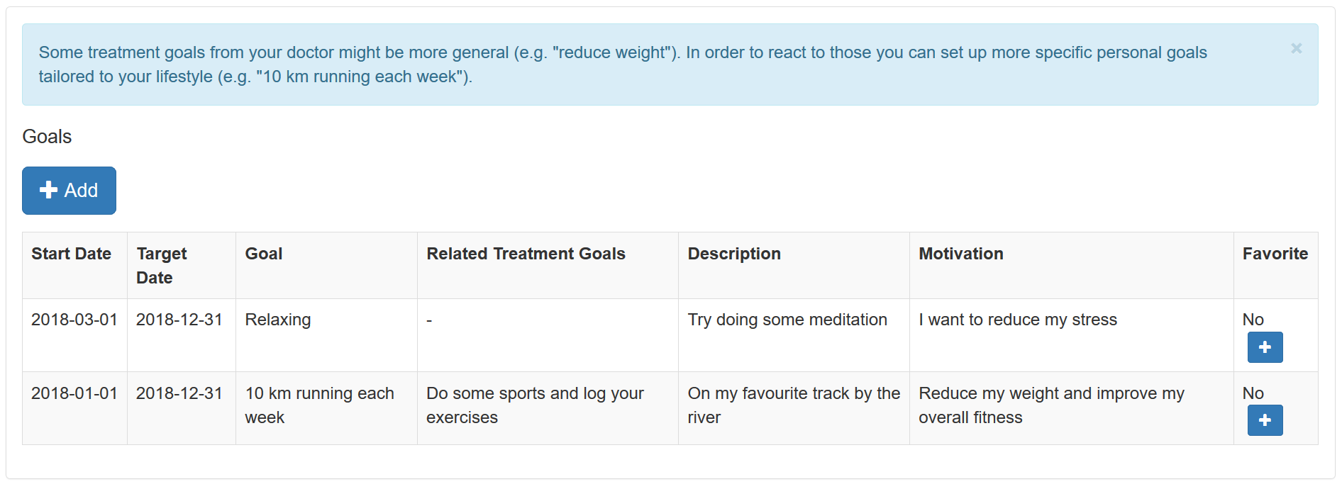
Figure 7: Self-Management Goals

First, all of your saved self-management goals are listed:

- Start Date and Target Date – indicate the valid period of your Goal
- Goal – describes the goal itself
- Related Treatment Goal – refers to the Related Treatment Goal specified by your doctor
- Description – includes a more detailed description of your goal for your reference
- Motivation – write down what motivates you to fulfil this goal (e.g. motivating ideas for when you finally have reached your goal).
- Favorite – one of the goals can be marked as "favorite goal”. For more information see section 5.8.

By using the button “+Add” new goals can be added. By clicking on existing goals you can edit or delete them.

Calendar

The purpose of the Calendar is twofold – It serves for the planning of activities supposed to help to achieve the goals defined before and if the planning of activities is done it gives an overview of already planned activities.

The Calendar Application lists all planned activities (see Figure 8). The week may be adjusted by using the navigation arrows. New activities can be added by choosing the button “+Add” or clicking on an empty calendar slot. Existing activities can be edited/deleted by choosing the corresponding activity on the left side of the Calendar.

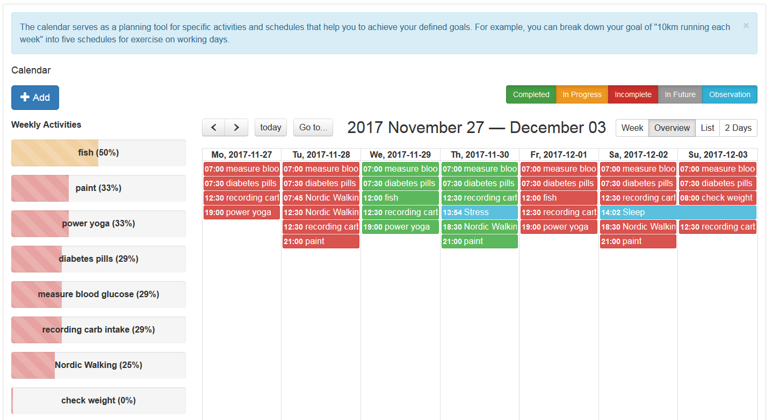
Figure 8: Calendar Application

The buttons on the top right side represent different states of an activity:

- Completed (green) – activities effectively performed
- In Progress (yellow) – activities that are currently performed
- Incomplete (red) – activities planned, but not performed
- In Future (grey) – upcoming and future activities
- Observations (blue) – additional observations recorded in a journal

You can enable and disable these states by clicking on the appropriate button.

By clicking on a calendar event, you can insert data (e.g. your blood glucose values) to complete an activity for that scheduled time. When completed, the colour of the activity will turn from e.g. red to green.

Stored activities may be shown in different views:

- Week – presents a calendar view (see Figure 9)
- Overview – presents an overview of all activities for each day of a week (see Figure 8)
- List – presents a list view of all activities for the selected week
- 2 Days – presents an overview of two days (today and tomorrow)

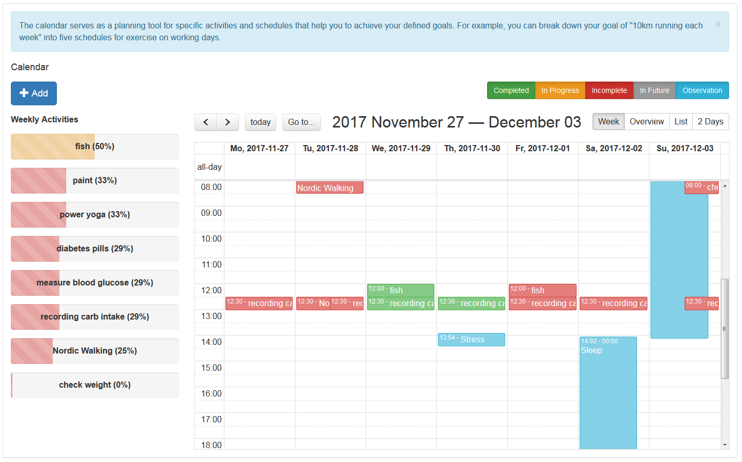
Figure 9: Calendar View (Week)

By clicking on "+Add" or on an entry in the left column "Weekly Activities" a window for managing activities opens (see Figure 10). You can add new entries or edit or delete the respective entries. The fields required for the entry are marked with "*", add or edit must be confirmed with "Save", a delete with "Delete".

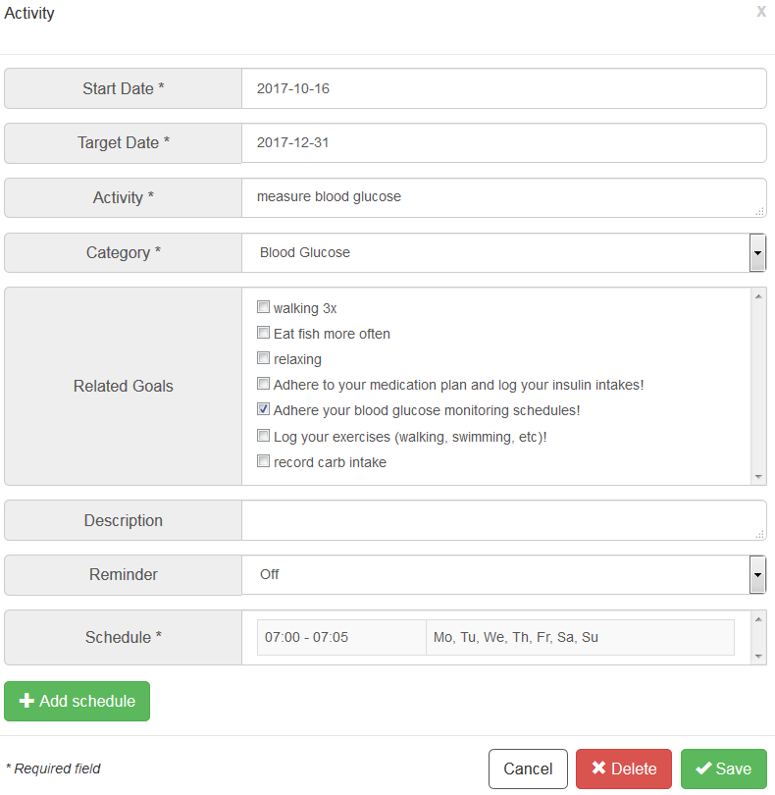
Figure 10: Adding an activity

The activity-related schedule is created in a separate window. Click on "+Add schedule" or on a table entry in "Schedule" to open the window (see Figure 11) in which you can add new entries or edit or delete the respective entries. The fields required for the entry are marked with "*", and add or edit must be confirmed with "Save", a delete with "Delete". Schedules can either be time-based (fixed time) or event-based (relative timing according to the Timing Settings – see section 8.2.). Please note that you must include at least one schedule to finally save an activity.

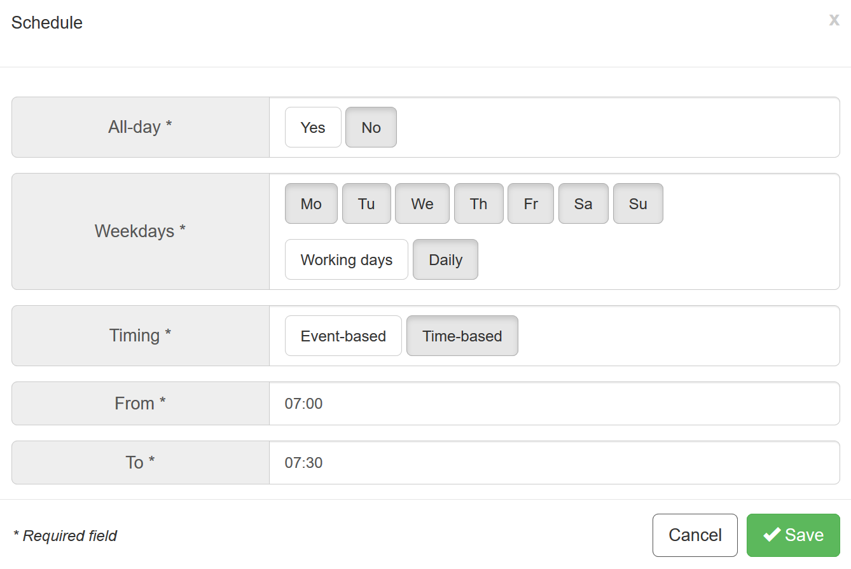
Figure 11: Scheduling an activity

Review

The review provides you with comprehensive feedback on your performance and should be reviewed regularly – at least once a week. The review aims at examining past activities and their recordings in order to evaluate your progress and how successfully you have met your goals. It covers your overall performance, feedback on the different categories of activities, feedback on additional recorded data in your journals and feedback on each goal. You can receive specific tips for each point.

Overall Performance

The review starts with selecting the review period in the top right corner (see Figure 12). The default period is the past week, however longer periods are also possible (e.g. last month). Before you perform the review, you should check whether you have recorded all the data for the review period. For this reason, click on the button “Show/hide calendar” and fill in any forgotten entries. The Overall Performance indicates how successfully you have completed your planned activities in total within the review period.

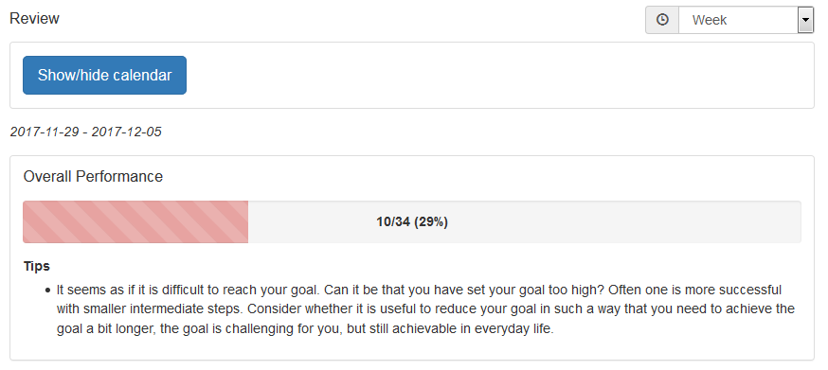
Figure 12: Review – Calendar & Overall Performance

Activity Feedback

Next, the system provides feedback how successfully you have completed your planned activities for each category (see Figure 13). The column “Performance” describes the performance in percent (e.g. 57%) and indicates the number of completed activities (e.g. “4/7” means 4 activities from 7 activities were completed). Also additional observations of the activity type that could not be assigned to a specific activity are counted (e.g. +1). The column “Tips” either acknowledges your progress or provides tips for improving your diabetes self-management.

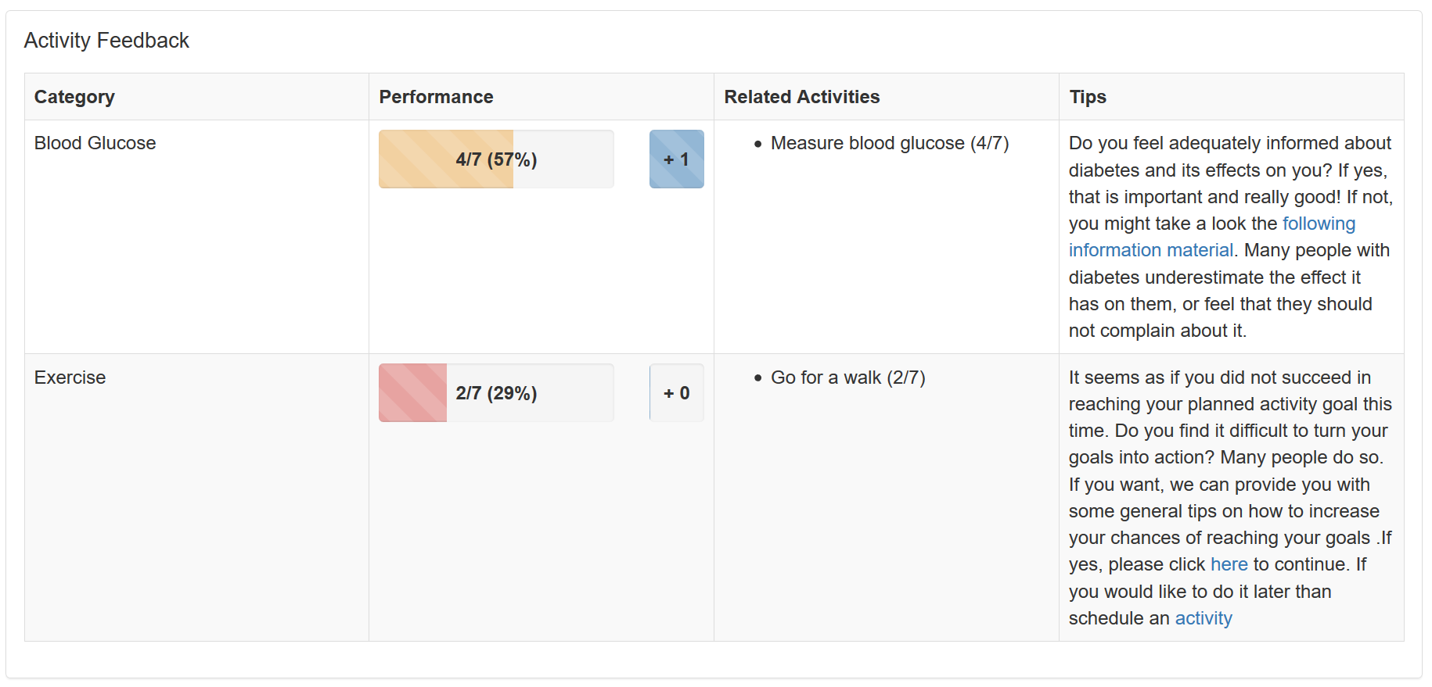
Figure 13: Review – Activity Feedback

Journal Feedback

The review menu item gives also feedback (tips) on additional data you record in your journals (see section 6 for journals).

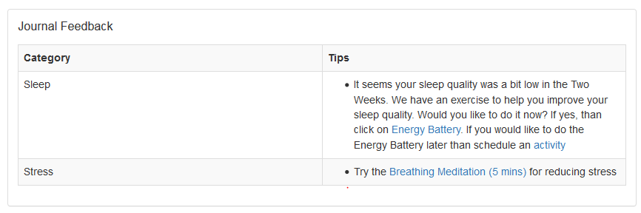
Figure 14: Review - Journal Feedback

Goals Feedback

Typically, activities are associated to personal goals. This step (see Figure 15) presents you an overview how successfully you have met your goals with the activities of the review time-range. A goal can be related to one or several activities.

The column “Performance” describes the performance in percent (e.g. 57%) and indicates the number of completed activities that are related to the associated goal (e.g. “4/7” means 4 from 7 activities were completed and have contributed to the associated goal). The column “Tips” acknowledges your progress and provides tips for improving your diabetes self-management.

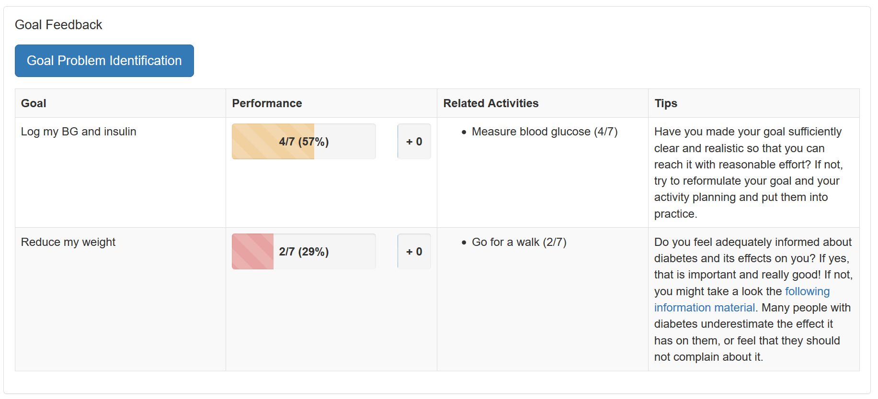
Figure 15: Review – Goal Feedback

The button “Goal Problem Identification” aims to support you in case you have problems to fulfil one of your goals. It opens a workflow guiding you with several questions to help better identify the problem that hampers your progress. Once identified, POWER2DM suggests an intervention to cope with the problem (see Figure 16). This workflow can also automatically identify and add barriers.

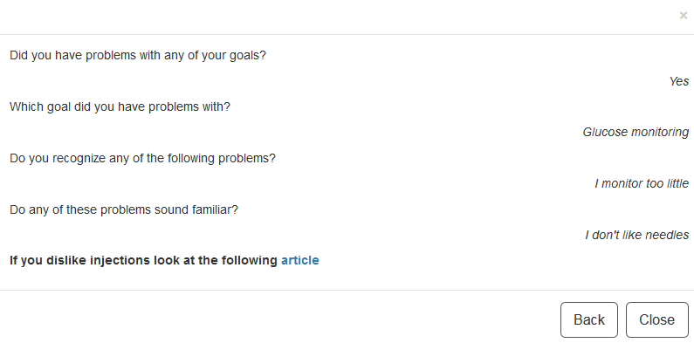
Figure 16: Goal Problem Identification

Charts

The diagrams provide you with a graphical presentation of the most relevant values ​​from the journals. With the help of the selection list you can switch between the available diagram types. For more information see section 5.4.

Charts

Different types of charts support the visualisation of the recorded observations and the evaluation of personal improvement respectively. To display a diagram, it is required

- to specify the time range in the select box in the top right corner and
- to select the chart type (select box “Chart Type”). Possible categories are blood glucose, blood pressure, exercise, meal, medication, mood, sleep, stress and weight

If you move the mouse pointer over a data point, you can see the detailed values.

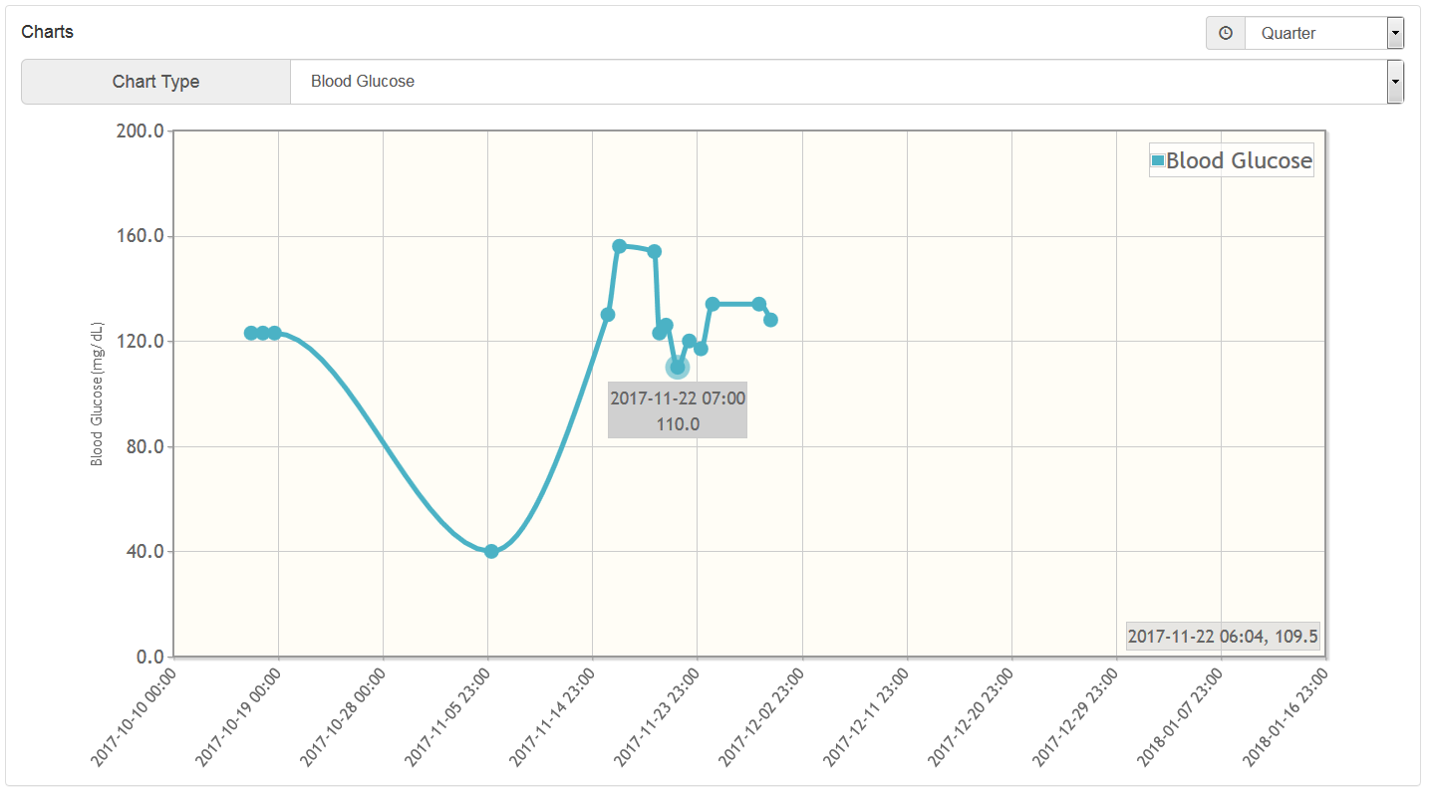
Figure 17: Charts

Energy Battery

The Energy Battery aims to increase your awareness of how you either gain or lose your energy to manage your health. Hints are provided on how you can recharge your energy.

In the first step (see Figure 18), the Energy Battery tells you about activity categories where you might lose energy and about activity categories that will help recharge your energy battery. You can also watch a video explaining the Energy Battery and these different activity categories.

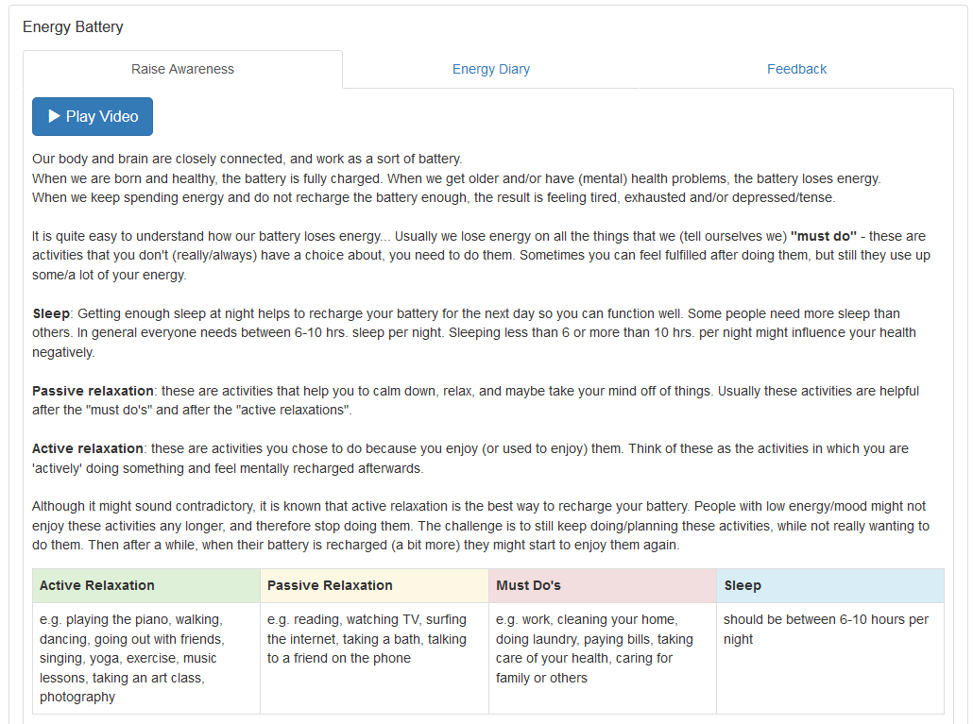
Figure 18: Energy Battery – Raise Awareness

In the next step (see Figure 19), you will be asked to record all your activities for the next 7 days and assign them to one of the four categories, explained in Step 1 (active relaxation, passive relaxation, must do’s, sleep), by using the button “+Add”.

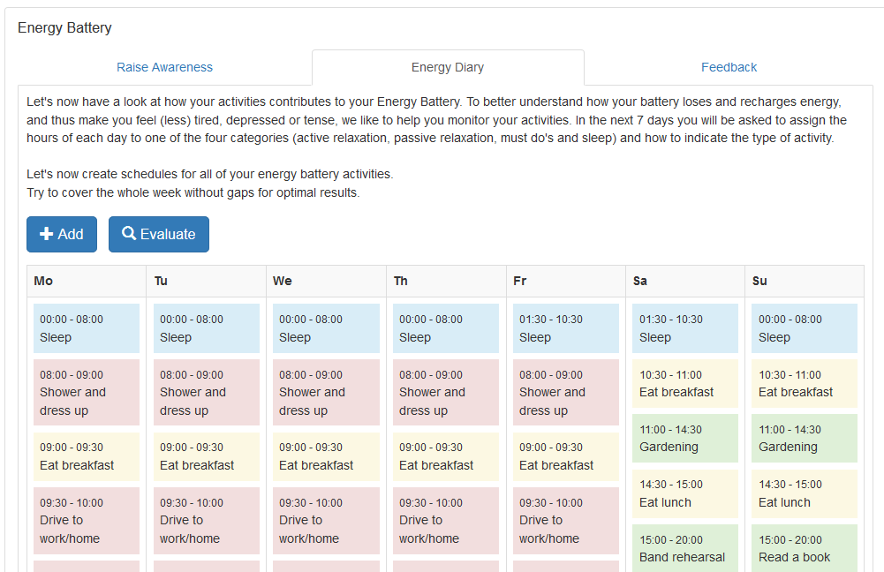
Figure 19: Energy Battery – Energy Diary

After 7 days, you can generally evaluate the recorded activities by pressing the button “Evaluate” (see Figure 20) to simply evaluate these activity categories (must do’s, the active and passive relaxation activities) based on your personal feeling.

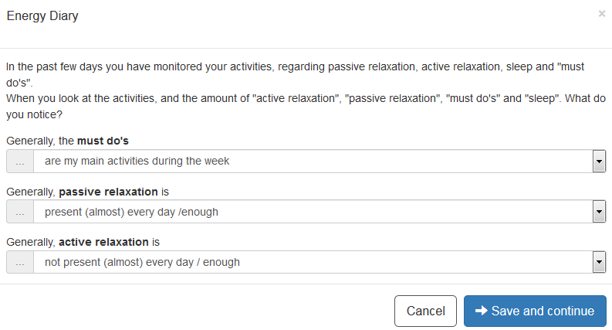
Figure 20: Energy Battery – Evaluation

In the final step (see Figure 21), the POWER2DM Energy Battery provides some feedback with hints based on your personal evaluation.

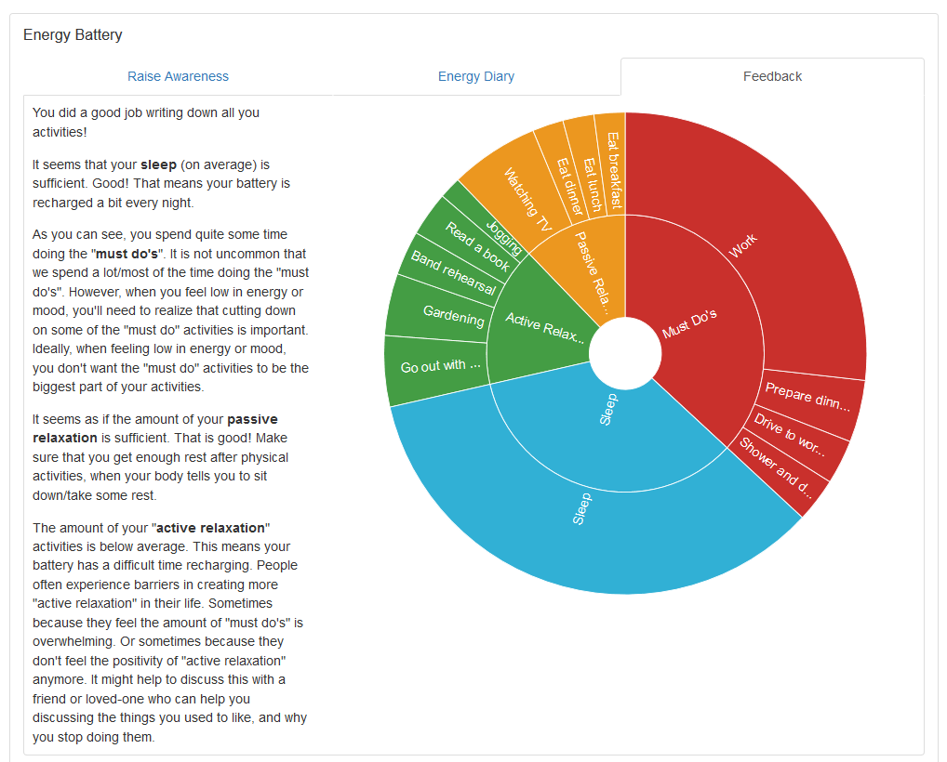
Figure 21: Energy Battery – Feedback

Value Compass

People with diabetes are faced with the difficulty of integrating diabetes in their daily lives. Their personal goals in daily life (regarding family, work, sports, leisure) may conflict with their diabetes self-management. And it may feel as if they constantly have to choose between their important personal goals and their health goals.

The Value Compass helps you to examine what is important to you in life, and how your diabetes relates to those important things. The Value Compass guides you through a journey by several steps for finding out how to integrate diabetes in your daily life positively, while doing all the things that are important to you. The exercise invites you to think about the following questions by looking at one or several of your life areas (see Figure 22):

What would you want your life with diabetes to look like, if you could choose how you took care of your diabetes without any limitations?

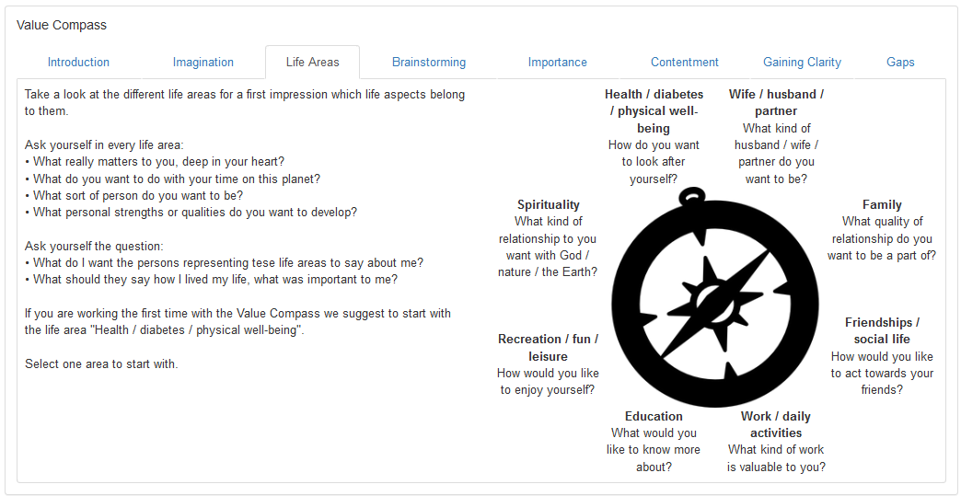
Figure 22: Value Compass – Life Areas

Next, you select one of these life areas and think what is important to you in this area (see Figure 23). This step is two-fold. First, you can do some brainstorming. When you have written down all your ideas you should summarize the quintessence of your thoughts in a Key Sentence. You will need this Key Sentence in the next steps of the Value Compass.

There is no need to work on all life areas. Start with one, preferably with “health / diabetes /physical well-being“. You can come back later for working on more life areas or for updating an existing one.

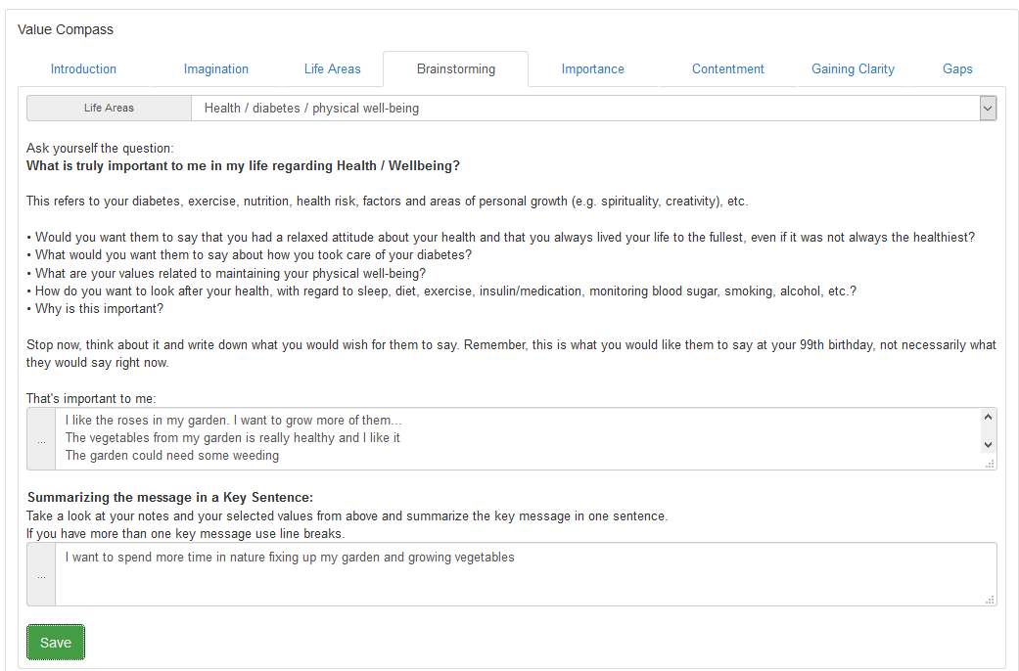
Figure 23: Value Compass – Brainstorming

In the next steps you rate how important these key sentences are for you (see Figure 24) and how content you are with them (see Figure 25).

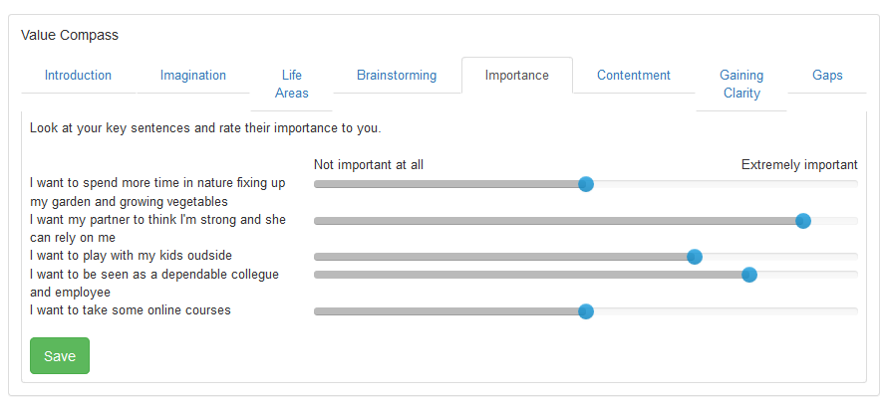
Figure 24: Value Compass - Rating Importance

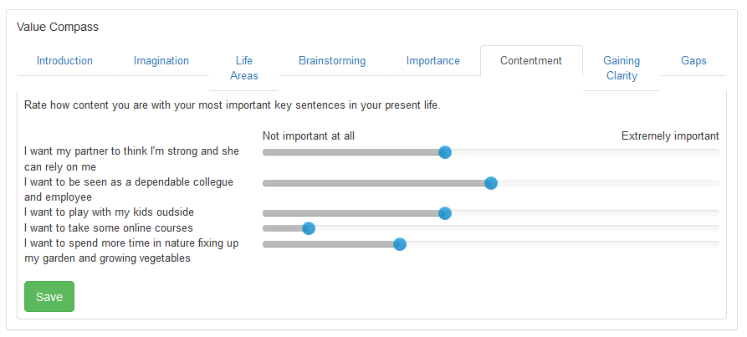
Figure 25: Value Compass - Rating Contentment

The step “Gaining Clarity” gives you a graphical overview about how you have rated importance and contentment for your key sentences (see Figure 26).

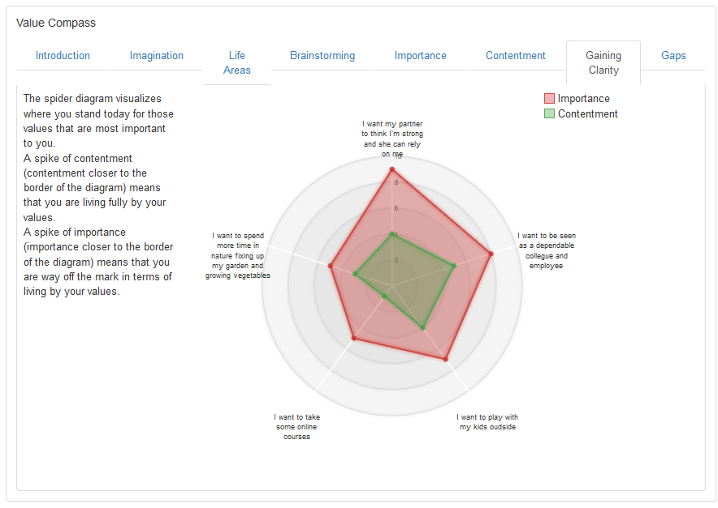
Figure 26: Value Compass - Gaining Clarity

In the final step (see Figure 27), the Value Compass presents an overview about those key sentences with high importance and low contentment. These gaps may indicate barriers hampering you to live your values to their full extent.

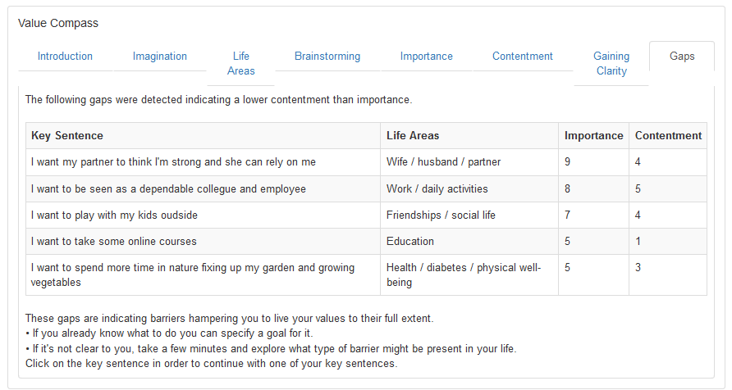
Figure 27: Value Compass – Gaps

Relaxation Tips

The relaxation tips help to provide you with your own personal tips in stressful situations. You should revise and / or expand this list according to your preferences.

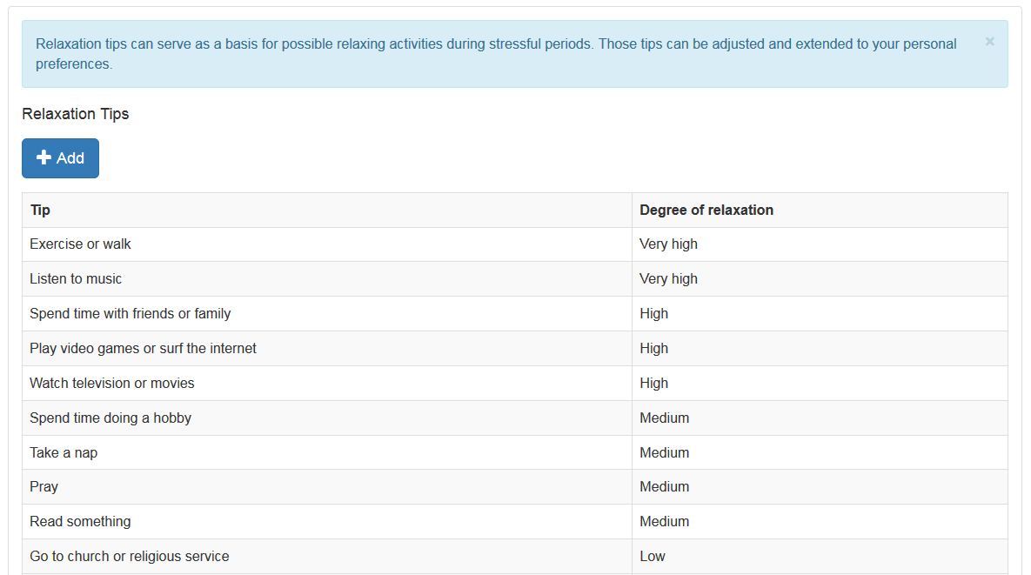
Figure 28: Relaxation Tips List

Click on "+Add" to add new relaxation tips. Click on an existing tip in the table to open a window (see Figure 29) where you can edit or delete the respective tip. The fields required for the entry are marked with "*", add or edit must be confirmed with "Save".

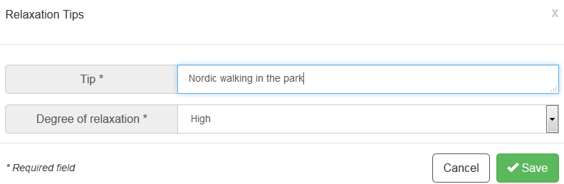
Figure 29: Relaxation Tips – Adding a personal tip

Favorite Goal

Sometimes users might be overstrained when they are coping with several goals. Often it is easier for them to focus just on one goal and when this goal is sufficiently reached to focus on the next goal. For supporting this approach POWER2DM offers an additional concept: focusing on a favorite goal by choosing one goal that you want to achieve.

Activating Favorite Goal implies the following steps:

- Set a Favorite Goal: Mark a goal as “Favorite” (see section 5.1.). You can just one goal mark as “Yes”.
- Plan activities for the Favorite Goal: Add one or more activities for your Favorite Goal (see Section 5.2. for adding a goal)
- Daily questions: POWER2DM will insert now two activities for each day in your calendar, one activity in the morning and one activity in the evening. The name of these activities is the name of your selected favorite goal. The activities will prompt you with questions about importance/contentment in the morning and stress/mood in the evening.
- Review for the Favorite Goal: The Review menu item contains an additional entry for the Favorite Goal in the section Goal Feedback giving you a specific feedback on your Favorite Goal. If you have not fully fulfilled the activities for this goal, the column “Tip” will recommend you an exercise for improving your degree of achievement for your favorite goal.

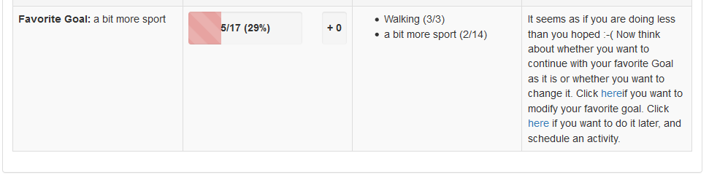
Figure 30: Review for the Favorite Goal

Journal

Your journals list all the values ​​you have recorded. In detail the following items can be collected:

- Blood Glucose
- Blood Pressure
- Comment
- Exercise
- Favorite Goal
- Meal
- Medication
- Mood
- Problem
- Sleep
- Stress
- Weight
- Well-Done Diary

By choosing a category (e.g. Blood Glucose, Exercise), the system lists all the stored entries of this particular journal category (see Figure 31 for Exercise). It is also possible to add a new journal entry by clicking on the “+Add” button. Any of the listed journal entries may also be edited/deleted by clicking on the corresponding row.

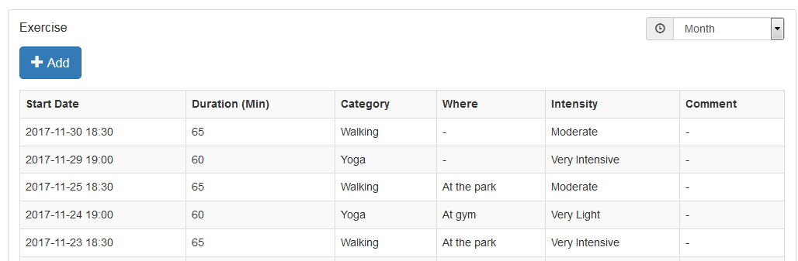
Figure 31: Journal - Exercise

Adding a new journal entry

Adding new journal entries is performed in a separate form that provides relevant input fields. Some of the input fields are optional, some mandatory. The latter are marked with a star “*” (see Figure 32). Whenever all mandatory fields are provided, it is possible to store the journal entry by pressing the “Save” button.

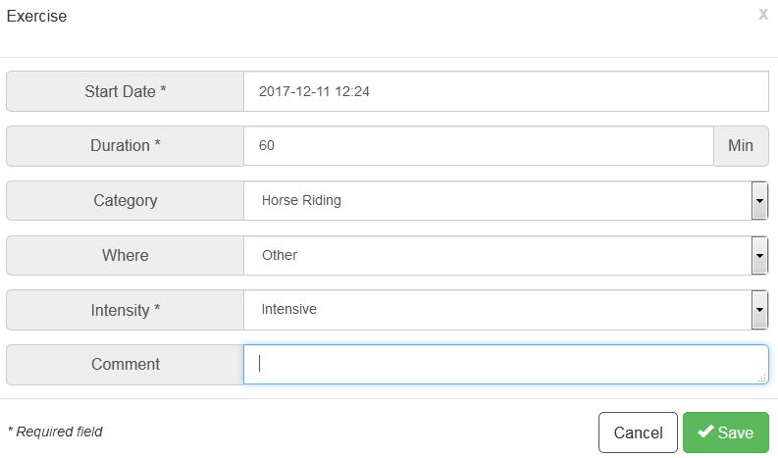
Figure 32: Journal Entry Form - Exercise

The following data types can occur during input:

- Date: You can enter the date manually in the format DD.MM.YYYY HH: mm (or English YYYY-MM-DD HH:mm) or use the widget that opens below the input window. By clicking on the clock or calendar icon you can switch between the selection of date and time (see Figure 33).

Figure 33: Inserting a date

- Number: You can specify the integer or decimal number (separated by a comma or period). The expected unit is indicated on the right (see Figure 34).

Figure 34: Inserting a number

- Text: You can enter a free text. By dragging the anchor at the bottom right edge, you can adjust the size of the input window (see Figure 35).

Figure 35: Inserting a text

- Selection: You can select one of the predefined options (see Figure 36).

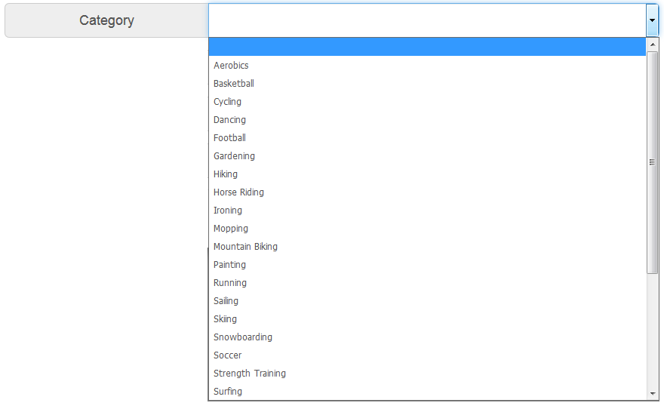
Figure 36: Selecting from predefined options

- Multiple selections: You can select several items by ticking the checkboxes. The options can be listed for clarity in a separate input window (see Figure 37). In this case, the current selection is shown on the right, by clicking on "Add xyz", the second input window is opened and by clicking on "Delete" the entire list can be emptied (see Figure 38).

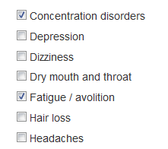
Figure 37: Multiple selection – selecting an option

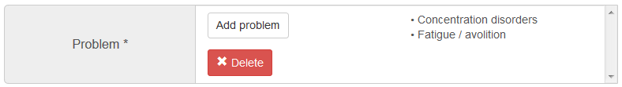
Figure 38: Multiple selection – overview

Information (“?”)

Clicking on the information symbol “?” provides further information. You are strongly encouraged to read this material carefully in order to gain knowledge about diabetes and the challenges when facing diabetes.

EMPOWER Information Material

When you choose the Info materials option by clicking on “POWER2DM Info Material”, you will be redirected to the public POWER2DM information site (see Figure 39). Here you may find answers to many questions ranging from what diabetes is to useful tips on how to manage diabetes in the day to day business.

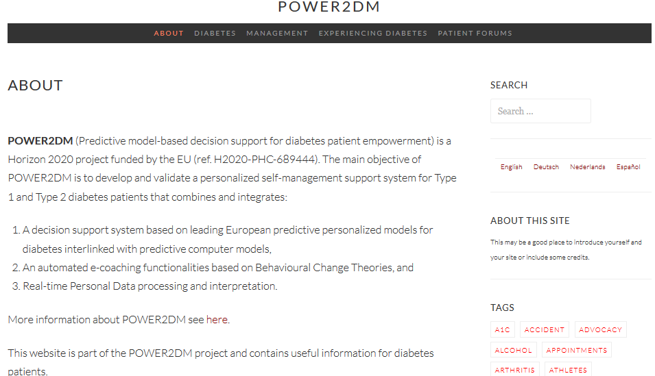
Figure 39: POWER2DM Information Material

The information material comprises the following categories:

- About: The homepage of the information material. There is also a list of tags of the most popular tags that link to related articles
- Diabetes: General information about diabetes, treatments and measurements
- Management: Information about nutrition and exercises
- Experiencing Diabetes: Articles about how to manage your emotions, about the daily life with diabetes, how to deal with signs of troubles, and what to do in case of being sick with diabetes
- Patient Forums: Established public patients’ forums

User Manual

On this page you will find the user manual you are reading. If your browser can open PDF files, then the document will be displayed directly - otherwise you can download it by clicking on "Download".

User Options

Settings

In the Settings (see Figure 40), you can make various adjustments concerning the display of your POWER2DM web interface, for example, your language preference.

You can configure the following items:

- Language: Possible languages are English, German, Dutch and Spanish
- First day of the week: You can insert the day of the week your calendar should start with
- Height: Body size in cm
- Dashboard elements: You can indicate which elements should be presented on your dashboard
- Hypo Threshold: Indicates the threshold for low blood sugar (hypoglycaemia)
- Hyper Threshold: Indicates the threshold when the blood sugar is too high (hyperglycaemia)
- Blood Glucose Unit: Blood glucose levels can be measured in mg/dL (milligrams per decilitre) or in mmol/L (millimoles per litre)
- Meal Unit: Possible meal units are gCHO (grams of carbohydrate) and BU (bread unit)
- Tips: You can choose whether to maximize or minimize the tips for the different menu items. In case you choose “Minimize” you can still toggle those tips by clicking on the “i” icon in the menu bar
- Animations: You can indicate if various interactive user interface elements (e.g. progress bars, charts) shall be animated or displayed without delay. Choosing “Off” can improve the performance on mobile devices

Changes must be confirmed by clicking on "Save".

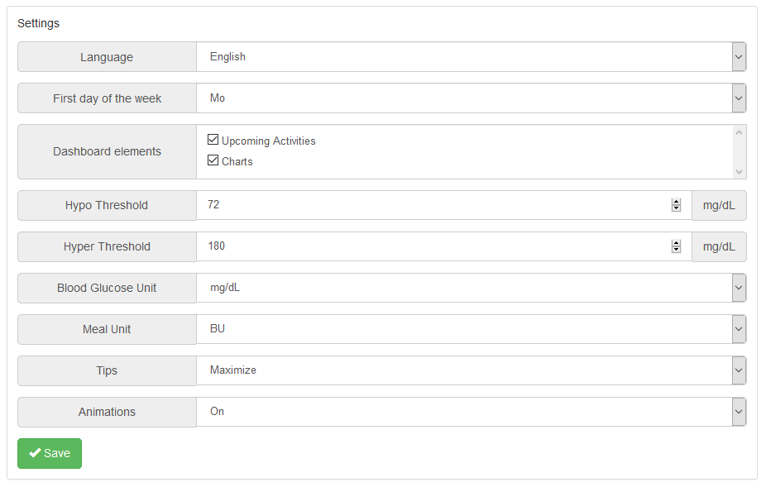
Figure 40: User settings

Timing

In the Timing (see Figure 41), you can change the absolute times used for event-based planning (see section 5.2.) – this can be done for weekdays and the weekend separately.

Changes must be confirmed by clicking on "Save".

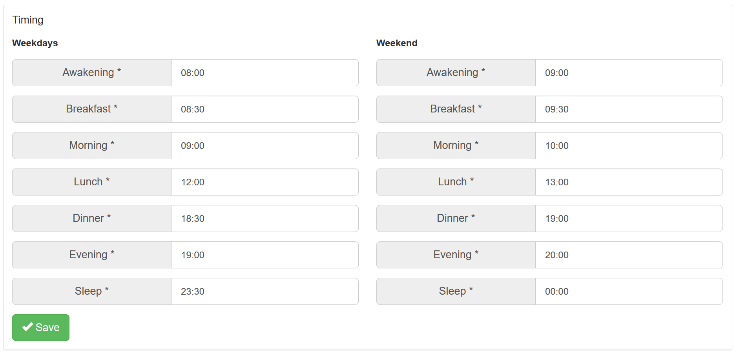
Figure 41: Timing

Logout

You can logout by selecting the submenu item “Sign out”.

hosted at https://p2dm.salzburgresearch.at/

